U18CO018

Shubham Shekhaliya

Assignment-1 (ST)

1-> To determine the volume of a cone by using the formula.

Code:-

public class q1 {

    static Scanner sc = new Scanner(System.in);

    public static void main(String[] args) {

        System.out.println("Please Enter base radius of the cone : ");

        double r = sc.nextDouble();

        System.out.println("Please Enter height  of the cone : ");

        double h = sc.nextDouble();

        double area = (Math.PI * r * r * h) / 3;

        System.out.println("Total Area of Cone : " + area);

    }

}

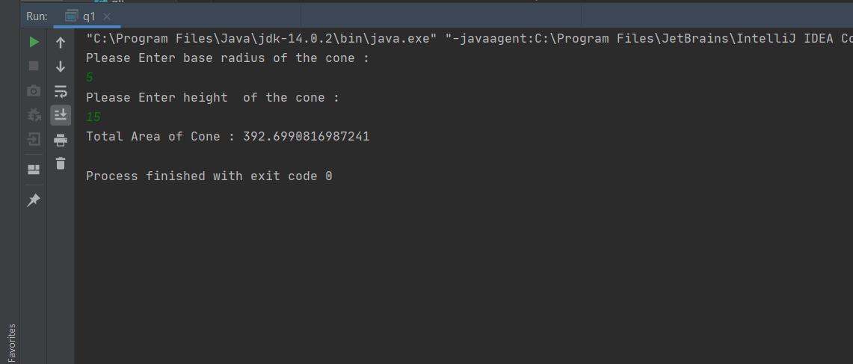

2-> Java Program to find LCM of two numbers.

Code:-

public class q2 {

    static Scanner sc = new Scanner(System.in);

    static int gcd(int a, int b) {

        if (b == 0)

            return a;

        return gcd(b, a % b);

    }

    public static void main(String[] args) {

        System.out.print("Enter First Number: ");

        int a = sc.nextInt();

        System.out.print("Enter Second Number: ");

        int b = sc.nextInt();

        int gc = gcd(a, b);

        int lcm = (a * b) / gc;

        System.out.println("Lcm of " + a + " and " + b + " is : " + lcm);

    }

}

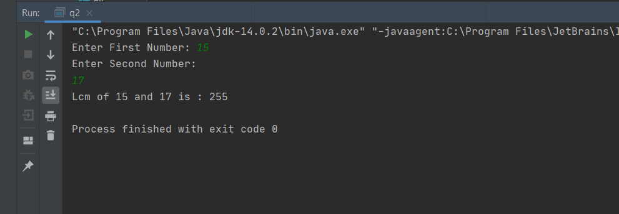

3-> Java Program to replace the spaces of a string with a specific character.

Code:-

public class q3 {

    static Scanner sc = new Scanner(System.in);

    public static void main(String[] args) {

        System.out.print("Please Enter a String : ");

        String s = sc.nextLine();

        s = s.replace(' ', '&');

        System.out.println("String after replacing spaces : " + s);

    }

}

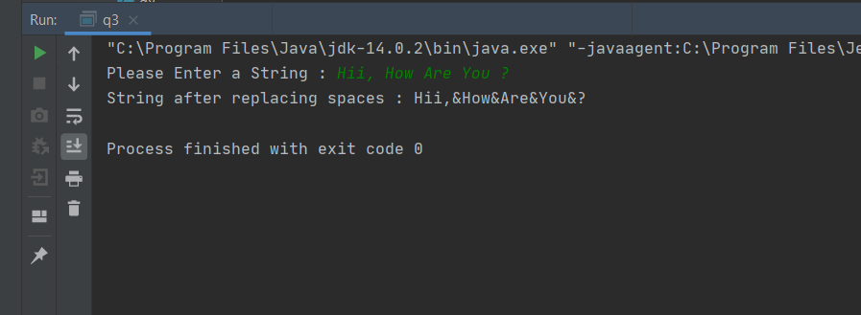

4-> Create a class which asks the user to enter a sentence, and it should display the count of each vowel type in the sentence. The program should continue till the user enters the word “quit”. Display the total count of each vowel for all sentences.

Code:-

public class q4 {

    static Scanner sc = new Scanner(System.in);

    public static void main(String[] args) {

        char vowel[] = {'a', 'e', 'i', 'o', 'u', 'A', 'E', 'I', 'O', 'U'};

        int[] count = new int[10];

        while (true) {

            System.out.print("Please Enter a String : ");

            String s = sc.nextLine();

            s.trim();

            if (s.equals("quit"))

                break;

            int[] temp = new int[10];

            for (int i = 0; i < vowel.length; i++) {

                for (int idx = 0; idx < s.length(); idx++) {

                    if (s.charAt(idx) == vowel[i]) {

                        temp[i]++;

                        count[i]++;

                    }

                }

                System.out.println("Number of " + vowel[i] + "'s : " + temp[i]);

            }

            System.out.println("   ----------------------    ");

        }

        for (int i = 0; i < vowel.length; i++) {

            System.out.println("Total Number of " + vowel[i] + "'s : " + count[i]);

        }

    }

}

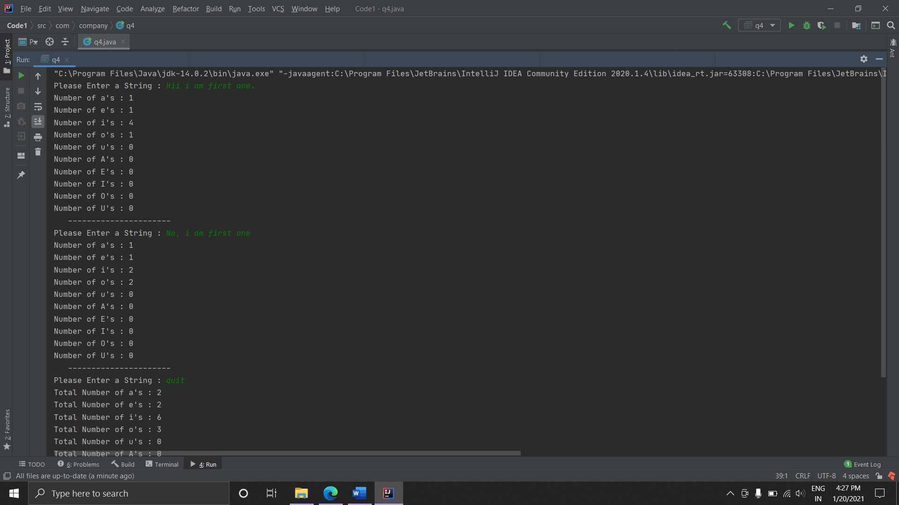

5-> Write a Java method to compute the future investment value at a given interest rate for a specified number of years.

Code:-

public class q5 {

    static Scanner sc = new Scanner(System.in);

    final static int NUMBER_OF_YEARS = 20; // Number of years to display

    public static double futureInvestmentValue(

            double investmentAmount, double rate, int years) {

        return investmentAmount * Math.pow(1 + rate, years * 12);

    }

    public static void main(String[] args) {

        System.out.print("\nThe amount invested: ");

        double amount = sc.nextDouble();

        System.out.print("interest rate: ");

        double rate = sc.nextDouble();

        rate /= 100;

        System.out.println("Years     Future Value");

        for (int years = 1; years <= NUMBER_OF_YEARS; years++) {

            System.out.printf("%-10d", years);

            System.out.printf("%11.2f\n", futureInvestmentValue(amount, rate, years));

        }

    }

}

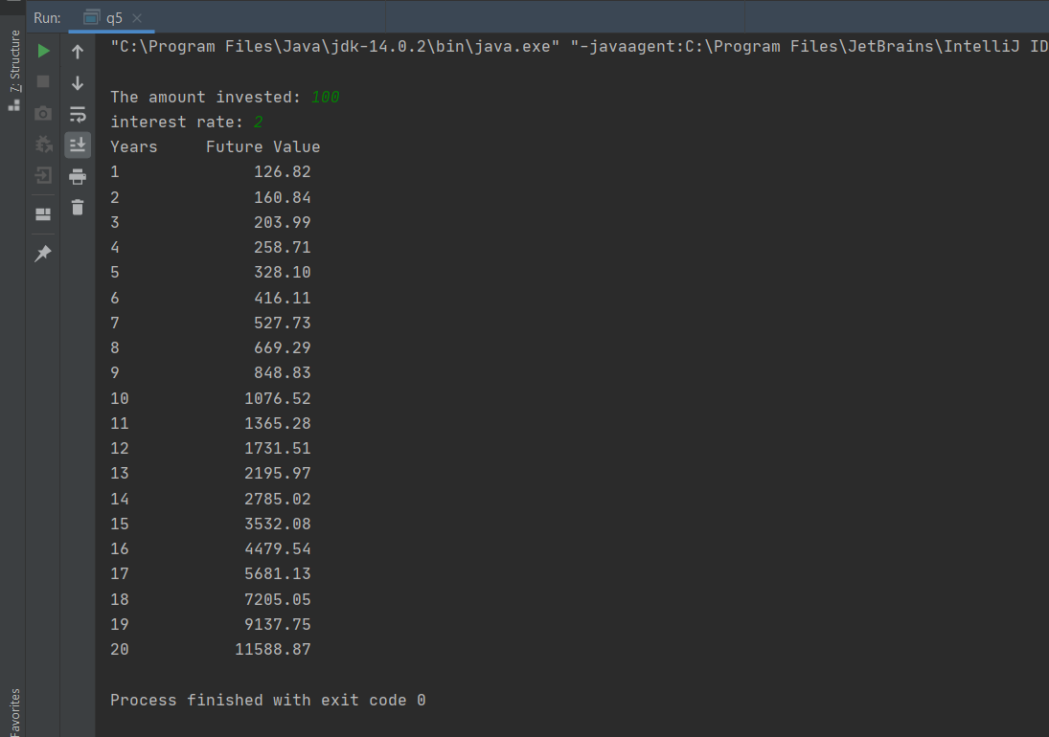

6-> Define a class student having roll_number as data member and two functions get_number() and put_number(). Derive a class test from a class student having marks of two subjects and two member functions two get and display marks. Derive a class result from a class test having total_marks as data member and a display function.

Code:-

public class q6 {

    public static void main(String[] args) {

        Result st1 = new Result(1, 85, 90);

        Result st2 = new Result(2, 50, 41);

        st1.ShowResult();

        System.out.println("------------------------------------    ");

        st2.ShowResult();

        System.out.println("------------------------------------    ");

        System.out.println("Roll No of student1 : " + st1.getRoll_no());

        System.out.println("------------------------------------    ");

        st2.setSubject2(80);

        System.out.println("subject2 marks of student2 : " + st2.getSubject2());

        System.out.println("------------------------------------    ");

        st1.setSubject1(50);

        System.out.println("subject1 marks of student1 : " + st1.getSubject1());

        System.out.println("Total Marks of student1 : " + st1.getTotal());

        System.out.println("------------------------------------    ");

        st1.setRoll_no(10);

        System.out.println("Roll No of student1 : " + st1.getRoll_no());

        System.out.println("------------------------------------    ");

        st2.setRoll_no(11);

        System.out.println("Roll No of student2 : " + st2.getRoll_no());

        System.out.println("------------------------------------    ");

        st1.ShowResult();

        System.out.println("------------------------------------    ");

        st2.ShowResult();

    }

    private static class Student {

        private int roll_no;

        Student(int rollNo) { this.roll_no = rollNo; }

        int getRoll_no() { return this.roll_no; }

        void setRoll_no(int rollNo) { this.roll_no = rollNo; }

    }

    private static class ClassTest extends Student {

        private int subject1, subject2;

        ClassTest(int rollNo, int subject1, int subject2) {

            super(rollNo);

            this.subject1 = subject1;

            this.subject2 = subject2;

        }

        public int getSubject1() { return subject1; }

        public void setSubject1(int subject1) { this.subject1 = subject1; }

        public int getSubject2() { return subject2; }

        public void setSubject2(int subject2) { this.subject2 = subject2; }

    }

    private static class Result extends ClassTest {

        Result(int rollNo, int subject1, int subject2) {

            super(rollNo, subject1, subject2);

        }

        void ShowResult() {

            System.out.println("Student roll No is " + this.getRoll_no());

            System.out.println("First Subject Marks " + this.getSubject1());

            System.out.println("Second Subject Marks " + this.getSubject2());

            System.out.println("Total Marks " + (this.getSubject1() + this.getSubject2()));

        }

        public int getTotal() { return getSubject1()+getSubject2(); }

    }

}

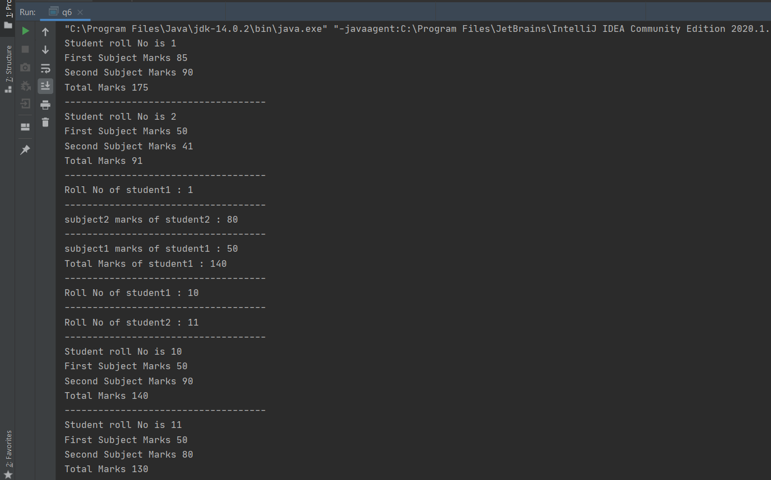

7-> Define a circle class with radius as data member, Add necessary constructors and member function to compute area of circle. Class should overload the = = operator to compare two circle objects whether they are equal in radius. Demonstrate its use in main().

Code:-

public class q7 {

    public static void main(String[] args) {

        Circle c1 = new Circle(10);

        Circle c2 = new Circle(20);

        Circle c3 = new Circle(10);

        System.out.println("Circle c1 : Radius = " + c1.getRadius() + " units, Area = " + c1.getArea() + " sq. units");

        System.out.println("Circle c2 : Radius = " + c2.getRadius() + " units, Area = " + c2.getArea() + " sq. units");

        System.out.println("Circle c3 : Radius = " + c3.getRadius() + " units, Area = " + c3.getArea() + " sq. units");

        System.out.print("c1 == c2 : ");

        if (c1.equals(c2))

            System.out.print("Circles are equal.\n");

        else

            System.out.print("Circles are not equal.\n");

        System.out.print("c1 == c3 : ");

        if (c1.equals(c3))

            System.out.print("Circles are equal.\n");

        else

            System.out.print("Circles are not equal.\n");

    }

    private static class Circle {

        private double radius, area;

        Circle(double r) {

            this.radius = r;

            area = Math.PI * r * r;

        }

        public double getRadius() { return radius; }

        public void setRadius(double radius) { this.radius = radius; }

        public double getArea() { return area; }

        @Override

        public boolean equals(Object o) {

            if (o == null || getClass() != o.getClass()) return false;

            Circle c = (Circle) o;

            return this.getRadius() == c.getRadius();

        }

    }

}

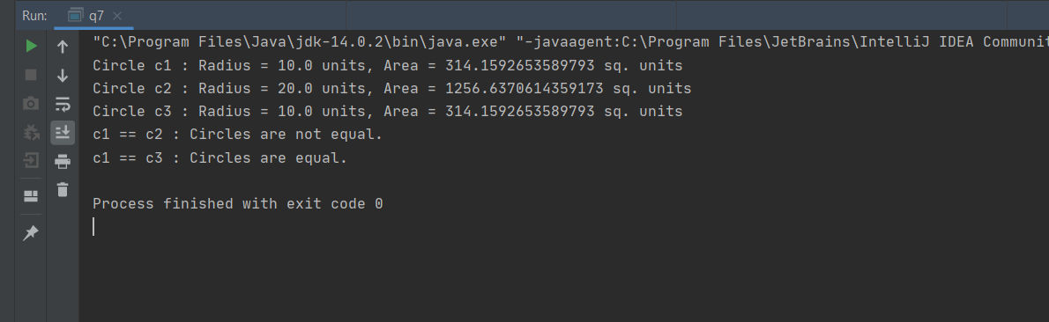

8-> Write a Java program that takes the user to provide a single character from the alphabet. Print Vowel or Consonant, depending on the user input. If the user input is not a letter (between a and z or A and Z), or is a string of length > 1, print an error message.

Code:-

public class q8 {

    static Scanner sc = new Scanner(System.in);

    public static void main(String[] args) {

        System.out.println("Please Enter Input : ");

        String str = sc.nextLine();

        char c = str.charAt(0);

        if (str.length() != 1) {

            System.out.println("Invalid Input");

        } else if ((c >= 'a' && c <= 'z') || (c >= 'A' && c <= 'Z')) {

            char vowel[] = {'a', 'e', 'i', 'o', 'u', 'A', 'E', 'I', 'O', 'U'};

            boolean check = false;

            for (int i = 0; i < vowel.length; i++) {

                if (vowel[i] == c)

                    check = true;

            }

            if (check) {

                System.out.println("Vowel");

            } else {

                System.out.println("Consonant");

            }

        } else {

            System.out.println("Input is not a letter");

        }

    }

}

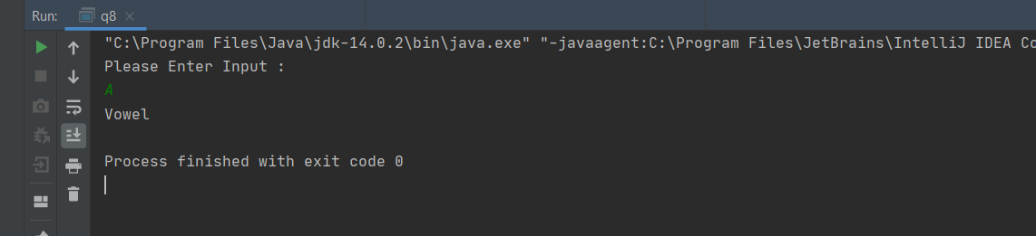

9-> Write a program that accepts three numbers from the user and prints "increasing" if the numbers are in increasing order, "decreasing" if the numbers are in decreasing

order, and "Neither increasing or decreasing order" otherwise.

Code:-

public class q9 {

    public static void main(String[] args) {

        Scanner sc = new Scanner(System.in);

        int n = 3;

        System.out.println("Enter Three numbers: ");

        int a = sc.nextInt(), b = sc.nextInt(), c = sc.nextInt();

        if (a <= b && b <= c) {

            System.out.println("increasing");

        } else if (a >= b && b >= c) {

            System.out.println("decreasing");

        } else {

            System.out.println("Neither increasing or decreasing order");

        }

    }

}

